Exemple with references
Table of Contents
1.1. Figure 2
1.2. Table 2

This is trop cool.

Figure
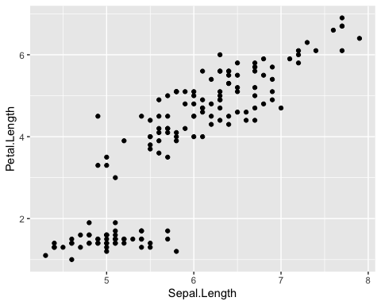

Table
Sepal.Length | Sepal.Width | Petal.Length | Petal.Width | Species
5.1 | 3.5 | 1.4 | 0.2 | setosa
4.9 | 3.0 | 1.4 | 0.2 | setosa
4.7 | 3.2 | 1.3 | 0.2 | setosa
4.6 | 3.1 | 1.5 | 0.2 | setosa
5.0 | 3.6 | 1.4 | 0.2 | setosa
5.4 | 3.9 | 1.7 | 0.4 | setosa

